**Docker**

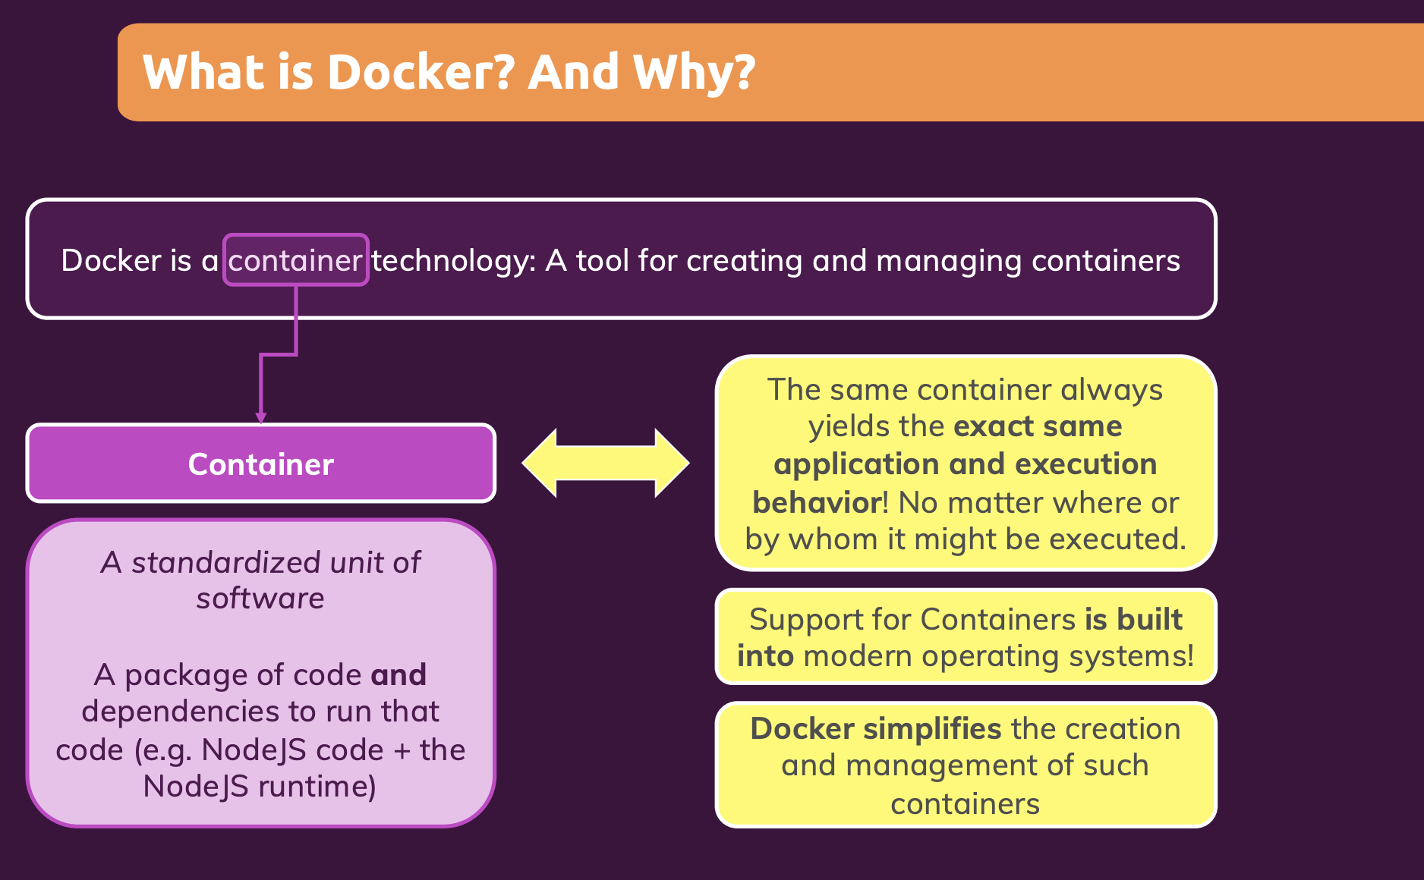

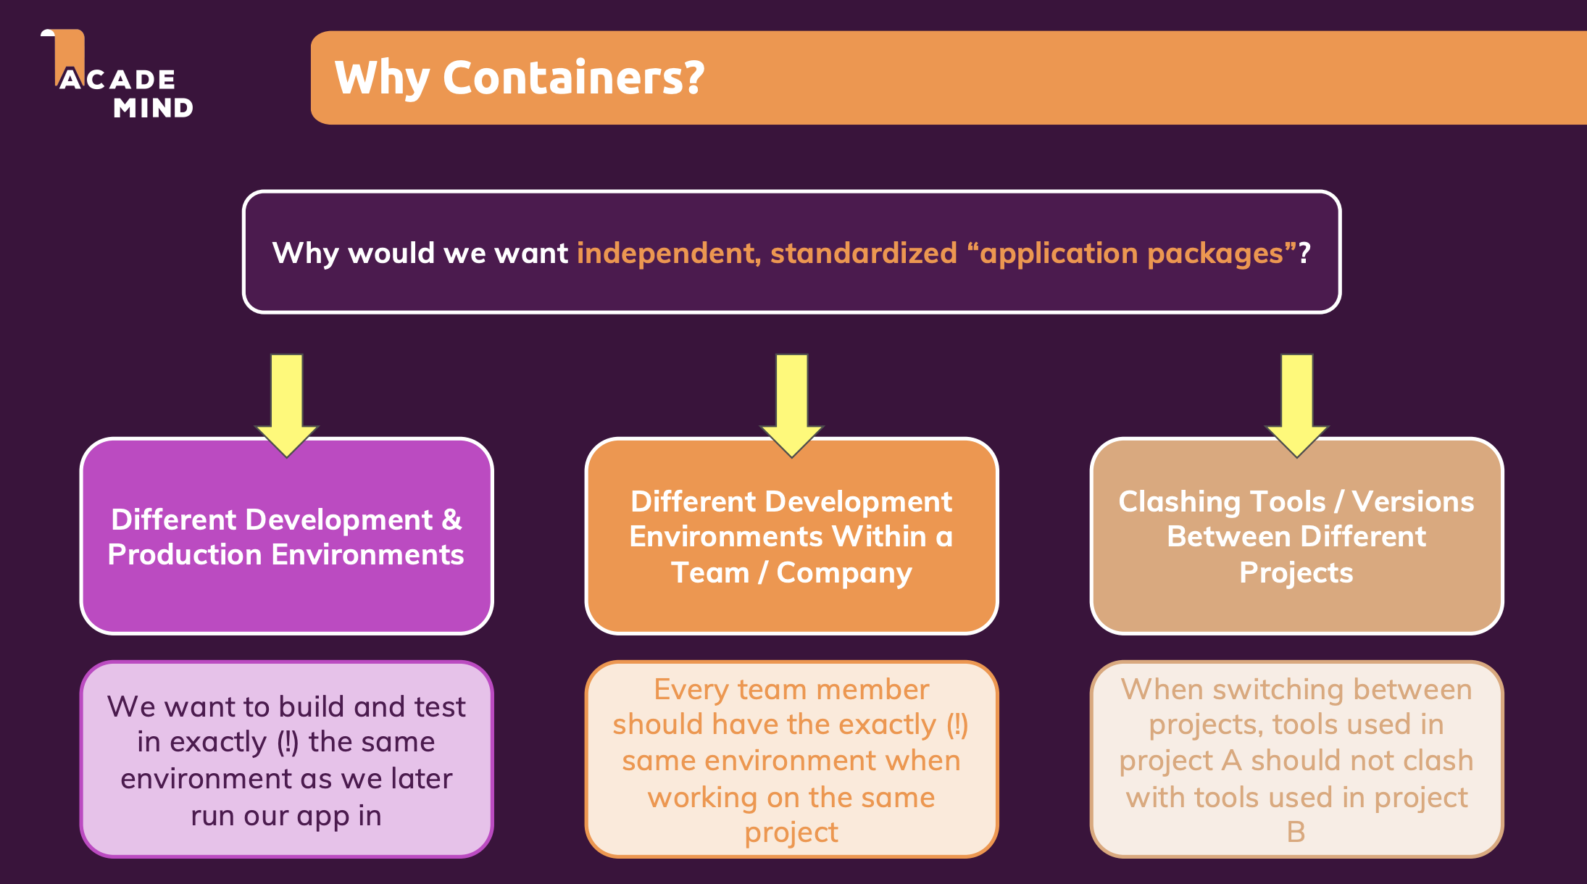

**Docker vs Virtual Machine**

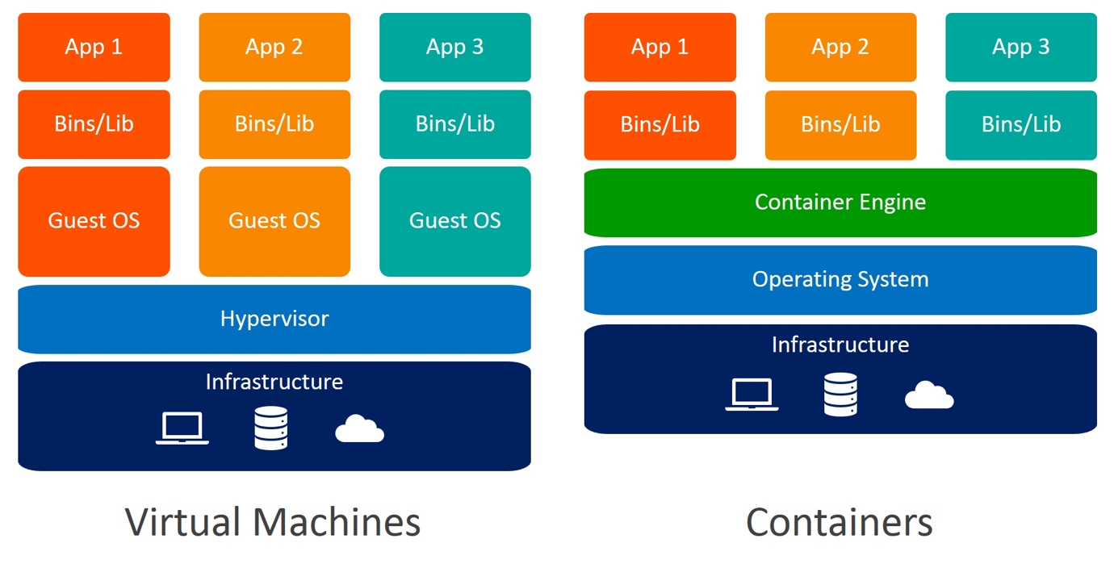

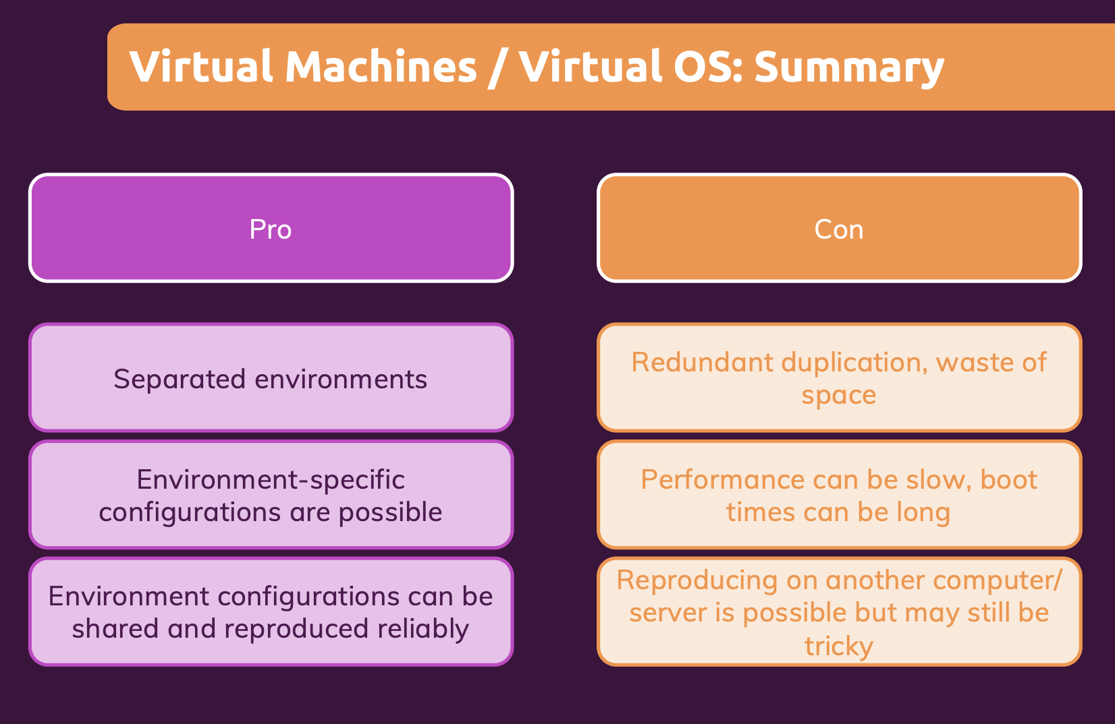

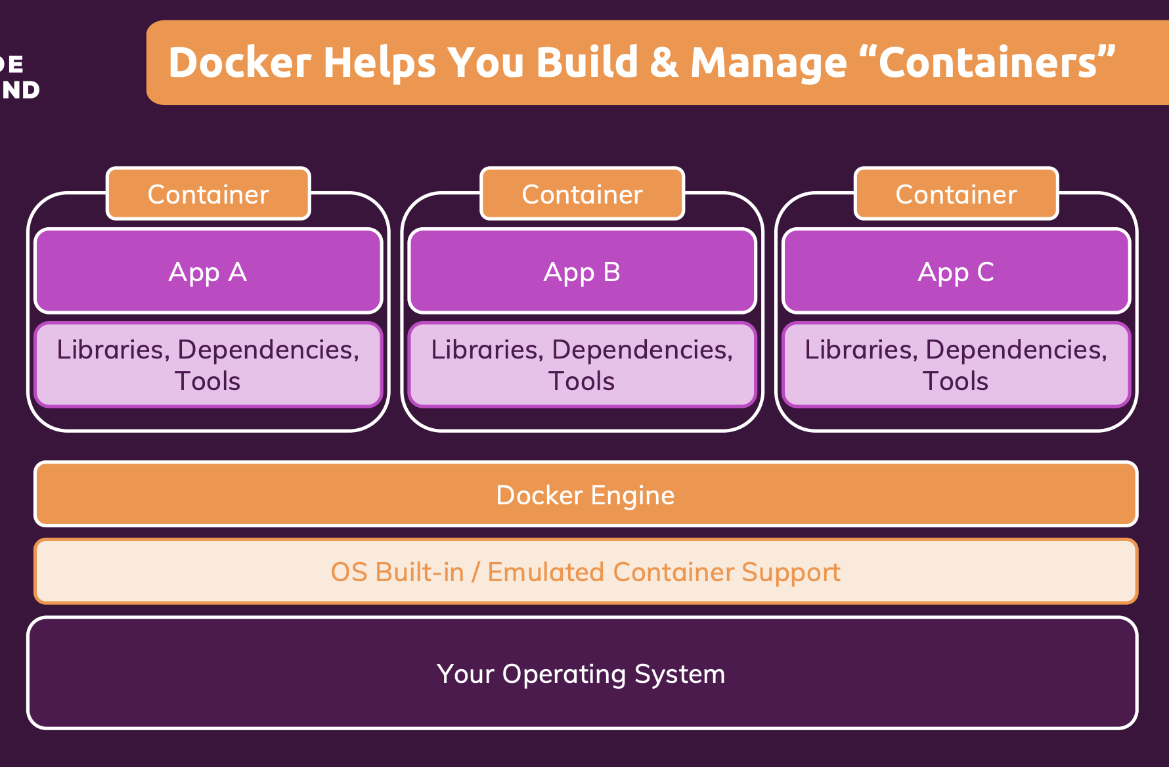

* To create a Docker Image, we first need to create a file by name “**Dockerfile”**.

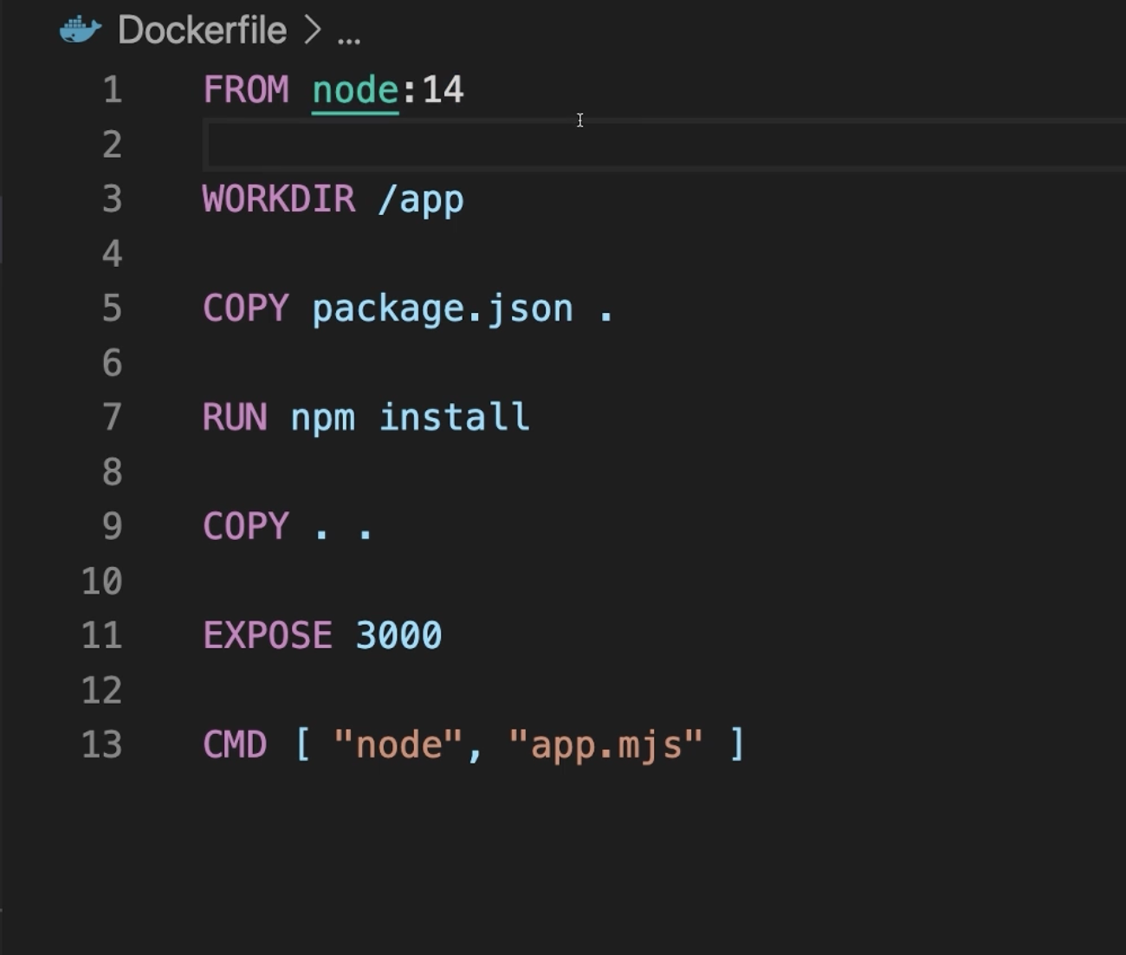

And then we execute app.mjs with the node command.

Then we expose port 3000 to the outside world.

Then we copy the rest of the code here.

Then we run the npm install command

We then copy the package.json file.

We have a certain directory in the container file system. Every container has its own file system. So that we want to have a special directory in there in which you wanna work.

We want to use Node.js as a base image so that we want to have Node.js available inside of our container.

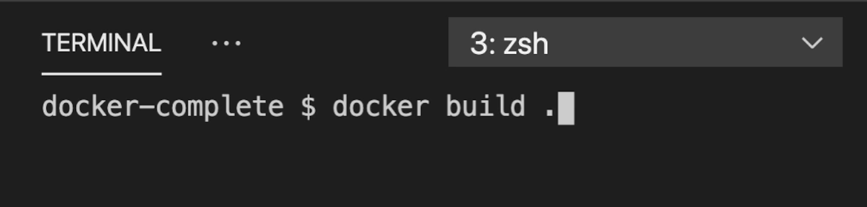

We run Docker build and this builds the image the Docker file. It finds in the directory in which you run this.

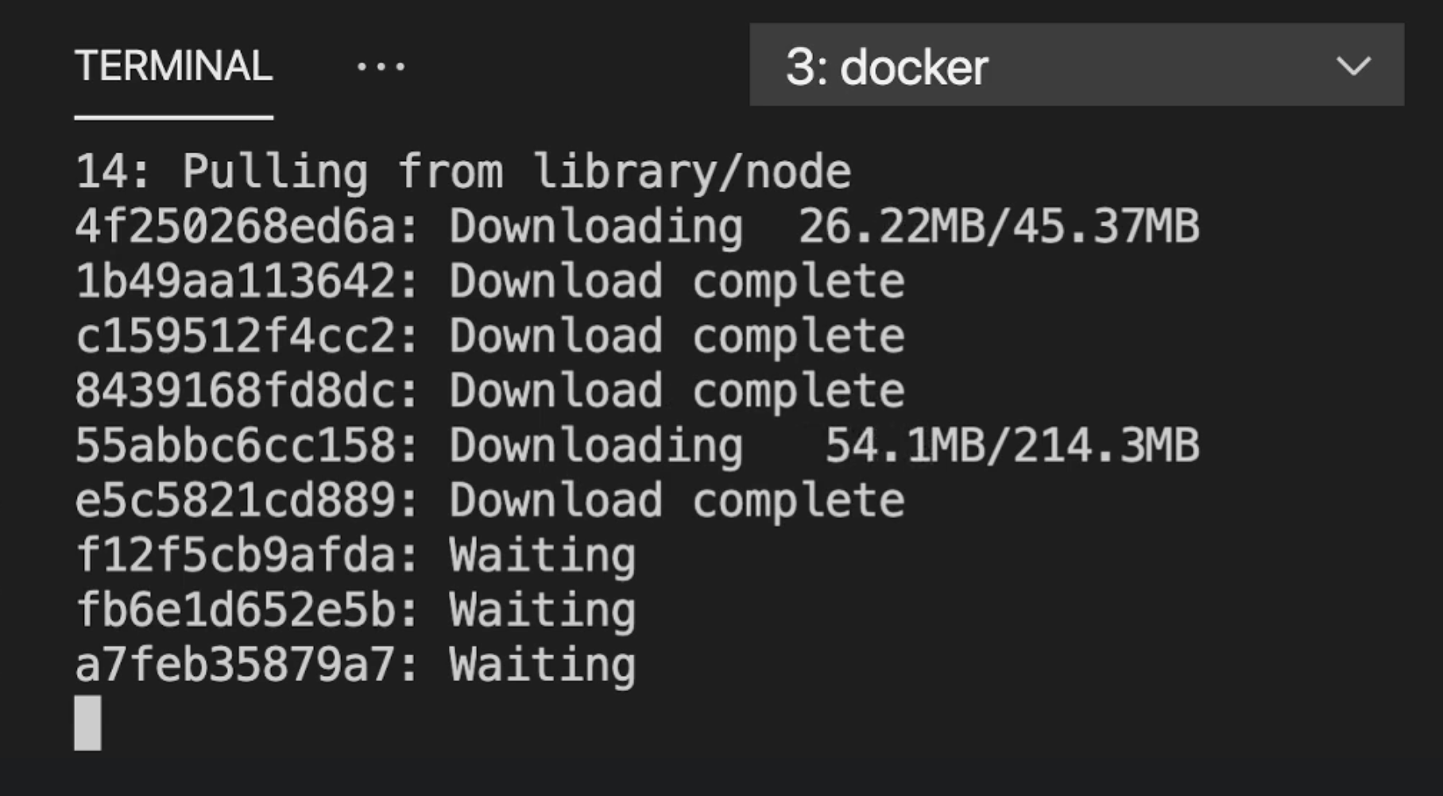

It runs and download/Install all the dependency required.

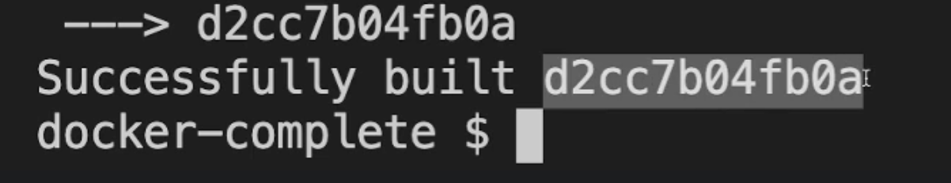

So this now walks through all these steps and after some time it should be done. You get a msg saying successfully built and then some ID for this image output.

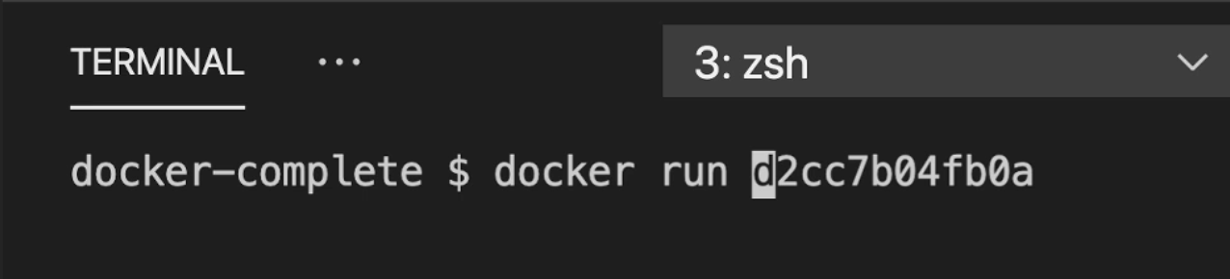

Now we can use this ID here, and then run a container based on this image with the docker run command.

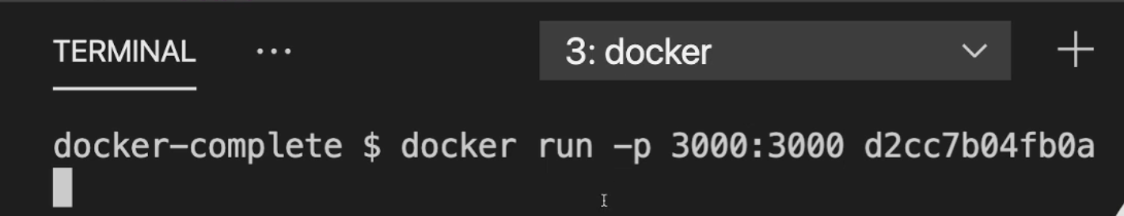

However, actually, since our container here has a port to which you wanna communicate, we actually need to publish that port on the container, which we want to run. And we do it as by adding the **-p** flag on docker run here. And we then publish port 3000 on port 3000.

Which means we can use our local host, on our local system to reach the application running on port 3000 instead of the container. Because by default, there is no connection between container and our host operating system. If we wanna send HTTP request for example,

to an application running in a container, we need to open up the port on the container to which we wanna communicate. Otherwise, it's a locked network in the container and we can't reach it from outside.

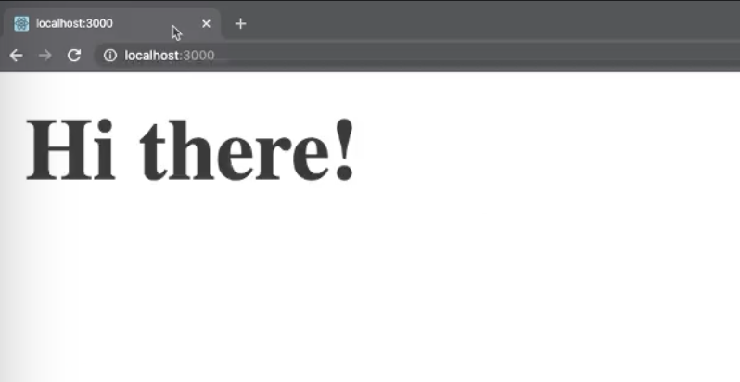

Now you can visit local host 3000, and you should see "Hi there!", there.

You can run ***docker ps***, which will list all running containers

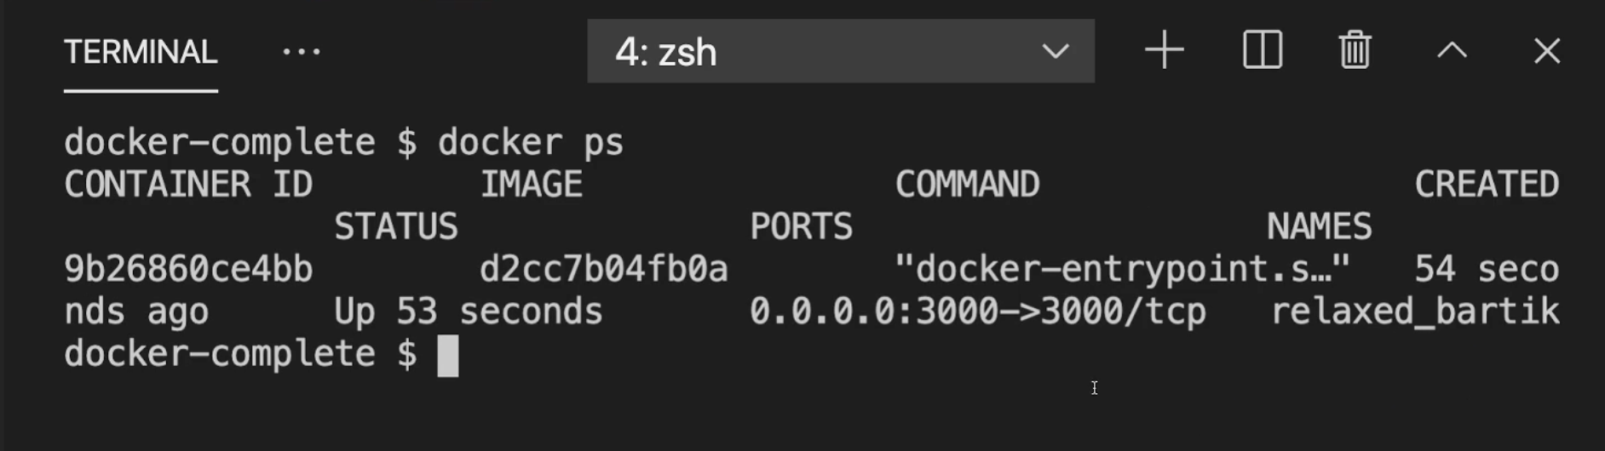

Run dockers stop, and then this name, and this will now stop this container and shut it down. This can also take a couple of seconds,

